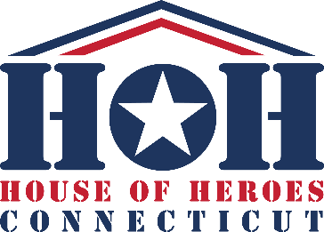

FOR IMMEDIATE RELEASE

Contact: Dennis Buden, House of Heroes Connecticut, 860-558-0514, dennisb@houseofheroesct.org

Two More Veterans, in Norwalk and West Haven, to be Honored and Served by House of Heroes Connecticut this Saturday

Project Partners Include Knights of Columbus/Norwalk, Greenwich Hospital and Annawon Lodge of Freemasons/West Haven; Total Vets Served Up to 312

July 23, 2026 – Two more Veterans, in Norwalk and West Haven, will be honored for their sacrificial service to our nation this Saturday, July 25, through the provision of no-cost home repairs by the non-profit Veterans Service Organization House of Heroes Connecticut (HOHCT).

The projects, the organization’s 311th and 312th since its 2012 founding, are being supported financially and through the provision of volunteer labor by Project Partners the Knights of Columbus Bishop Fenwick Assembly and Greenwich Hospital (Norwalk) and Annawon Lodge 115 of the Ancient, Free and Accepted Masons (West Haven).

Work begins at 8 a.m. at the Norwalk home of the late U.S. Army Veteran Ira Jack Gaylinn, a Korean War-era Veteran who passed in 2021 at age 92. The beneficiary will be Ira’s surviving spouse, Marlene Gaylinn. House of Heroes has long supported surviving spouses in need of those who served. The day’s second project, also starting at 8 a.m., will be at the West Haven home of 64-year-old U.S. Marine Corps Veteran Evin Hill, who served as a Communications Operator from 1979-1984 including overseas duty in Japan and Denmark.

Repairs at the Norwalk project will include front porch and street post repairs, including installation of a grab bar; a side yard fence installation; and back porch and walkway repairs among other minor tasks. In West Haven volunteers will resurface a rear deck, replace a bathroom faucet and complete yard clean-up tasks.

A 501(c)(3) non-profit organization, House of Heroes Connecticut recognizes, honors and serves military and public safety veterans and/or their surviving spouses in need for their sacrificial service to America through the provision of one-day, no-cost home repairs focused on safety and accessibility. The Connecticut Chapter is part of a national organization founded in Columbus, Georgia in 2000 that has served more than 2,400 Veterans across the country. For more information, visit www.hohct.org.

###

